

EASTERN MEDITERRANEAN UNIVERSITY

SOFTWARE ENGINEERING DEPARTMENT

CMSE424 IMAGE PROCESSING

LAB2

16700368 JORDAN MANANGA SIKU

FALL 2021-2021

1. INTRODUCTION

In 4th year in computer engineering department at Emu, we have Area electives courses. Theses are a list of courses where you have to pick one. For this semester, one of them CMSE425 IMAGE PROCESSING. In general, the course is about how images are processed. To practice what we are learning, we have Labs. This is the aim of this report, it is based on Lab 2.

1. Task Given

We were given 4 images, and using Matlab, we were asked to permed certains tasks. To avoid repeating the questions since it is in the lab sheet, we will proceed to the solution and result of the lab.

1. Lab Solution and Result

E1. After completing the shrink, zoom and rotate of each figure given using 3 interpolation techniques separately, here are screenshot of the result.

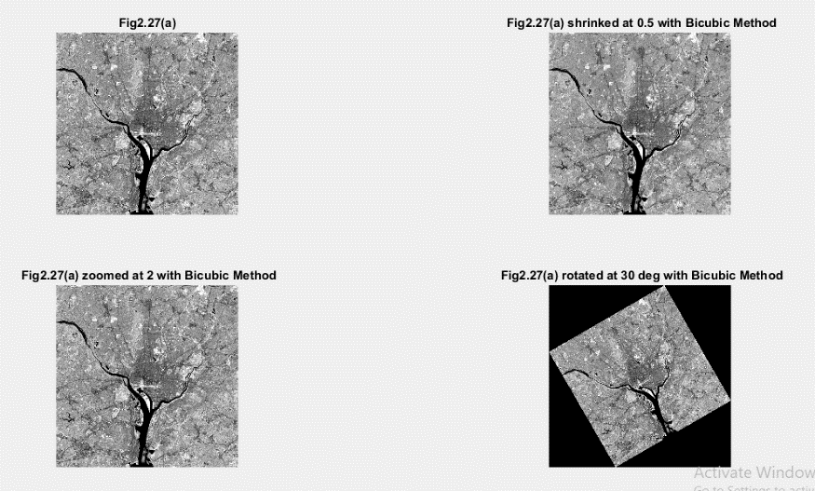

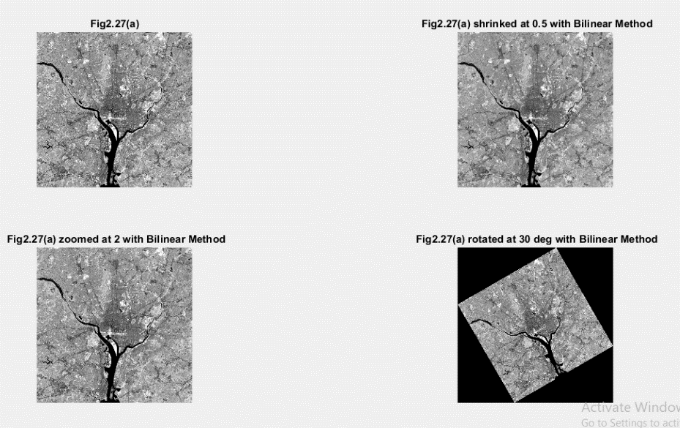

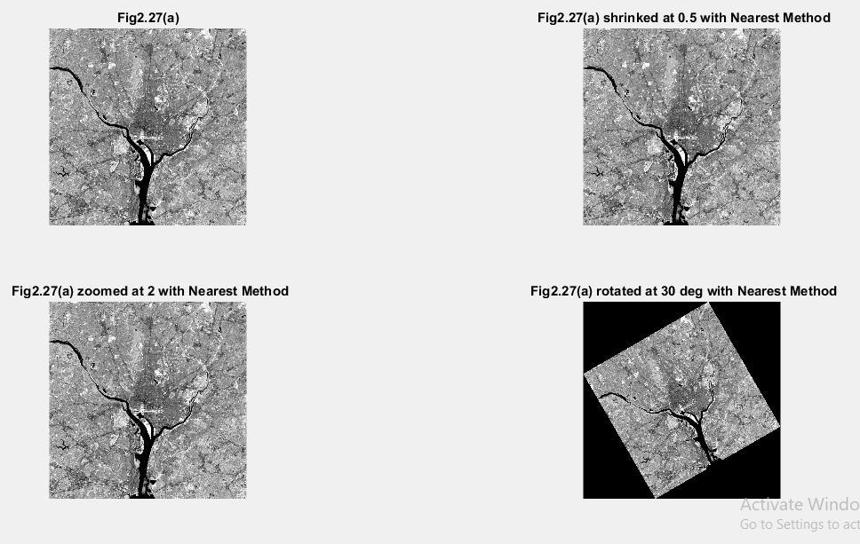

All the 3 tasks have been performed in this pictures. We don’t really see much difference of pictures with different methods (Nearest, Bilinear and Bicubic). However, we see a small alteration in pixel values when we compare different methods.

Here is the Matlab code performed:

im1=imread('Fig227a.tif');

% shrink

im2=imresize(im1,0.5,'Bicubic');

% zoom

im3=imresize(im1,2,'Bicubic');

%rotate

im4=imrotate(im1,30,'Bicubic');

figure,

subplot (2,2,1), imshow(im1), title ('Fig2.27(a)');

subplot (2,2,2), imshow(im2), title (' Fig2.27(a) shrinked at 0.5 with Bicubic Method');

subplot (2,2,3), imshow(im3), title (' Fig2.27(a) zoomed at 2 with Bicubic Method');

subplot (2,2,4), imshow(im4), title (' Fig2.27(a) rotated at 30 deg with Bicubic Method');

E2.

a)

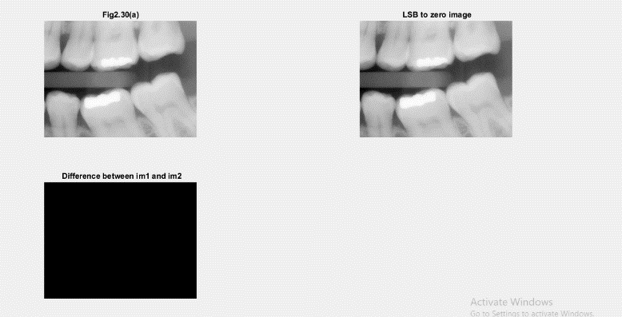

To obtain the Least significant bit (LSB) and the different image, we applied this code:

% change LSB to 0

im2=im1-rem(im1,2);

% difference between im1 and im2

im3=im1-im2;

The LSB is obtain by changing the last bit of a pixel by reducing it by one if it is odd and leaving it as it is if it is even.

We see that is no visible change between the original and the LSB image. But we subtract both images, we obtain an all-black image since all pixel values are either 0 or 1. Here is a Screen shot of the difference image pixel.

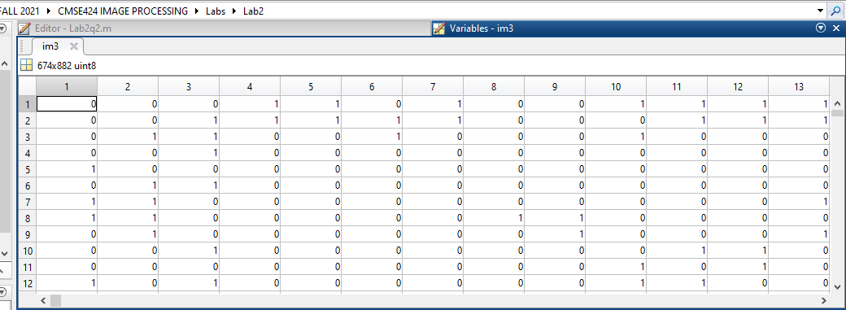

b)

Here is the Matlab code for the product image:

im1=imread('Fig230a.tif');

im2=imread('Fig230b.tif');

% prduct image

im3=immultiply(im2,im1);

Here is the Screenshot

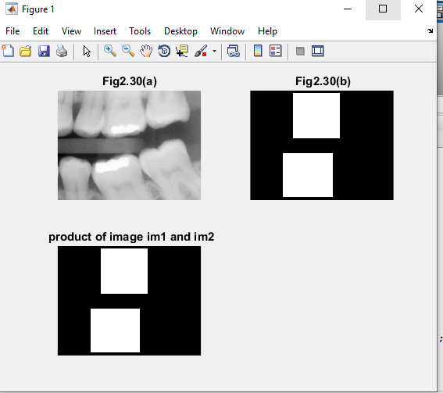

And we see that there is no visible difference between the figure b and the product image.

c)

To obtain the negative by doing the complement, this is the code:

im1=imread('Fig232a.tif');

% complement of an image

compim1=imcomplement(im1);

Here is the screenshot

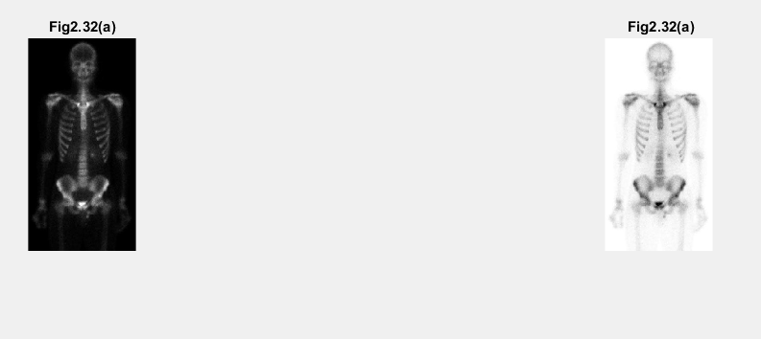

We observe that the background color is changed from black to white.